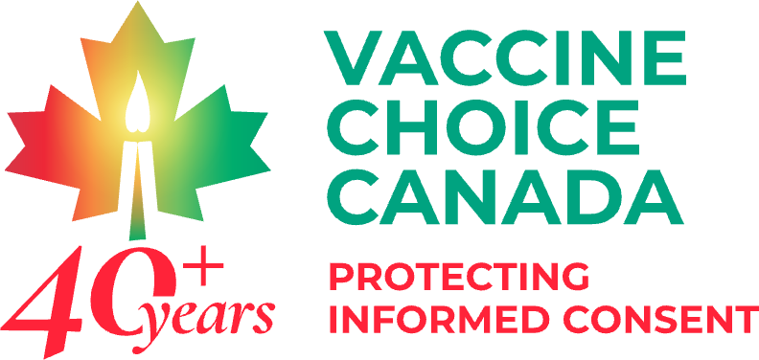

Dear Vaccine Choice Canada Community and Donors,
After much consultation and deliberation the Board of Directors of Vaccine Choice Canada have decided to file a ‘Notice of Discontinuance’ with regards to the legal action filed on July 6, 2020 (Court File No. CV-20-00643451-0000). Discontinuance means that a party, for its own reasons, has chosen not to continue the litigation. The decision to discontinue does not take away from the importance or merit of the case.
It is the position of the Board of Directors of Vaccine Choice Canada that to continue this legal matter at this time is not advisable. Our confidence in the independence and integrity of our Courts, and their willingness to properly consider the available facts and scientific evidence has been seriously eroded, past repair or hope. We are of the opinion that to participate in a fraudulent and illegitimate process is to give legitimacy to that process.
Our decision is based on the following considerations:
1. The Courts have clearly demonstrated their unwillingness to properly consider the facts as they relate to COVID-19, the evidence and lack thereof of a pandemic; the extent of harm caused by the so called “vaccine”; the extent of harm caused by measures and mandates imposed by governments including masking, social distancing, lockdowns, injection of a genetic material; lack of proper safety testing; the violation of our Charter Rights and Freedoms, and other matters related to the government’s response to the COVID-19 event.
2. The Courts have clearly demonstrated their unwillingness to consider expert testimony that challenges the claims of Health Canada, the CDC, and statements made by various government officials, officers and agencies.
3. The Courts have clearly demonstrated a deference, not to facts, the scientific method, and scientific evidence, but rather to government authorities, regardless of the inability of such authorities to justify their measures and mandates.
4. The Courts have utilized “judicial notice”, “mootness”, and “motion to strike” as instruments to deny full debate and disclosure of the available evidence.
5. The Courts have clearly demonstrated that they are not impartial with regards to the matter of the appropriate response to COVID, as is evidenced by their requirement that those attending court be compelled to wear a face covering, despite compelling evidence of the ineffectiveness of coverings in preventing transmission, and the harm from prolonged use of face coverings.
6. The Courts have clearly demonstrated that they are not impartial with regards to the matter of COVID and the appropriate response to COVID, as is evidenced by the Supreme Court judges publicly declaring their compliance with vaccine mandates that violate bodily sovereignty and informed consent.
7. The Courts have clearly demonstrated that they are not impartial with regards to the matter of COVID and the appropriate response to COVID, as is evidenced by the Supreme Court refusing to consider the appeal of lower court decisions that violate our fundamental rights and freedoms.
8. Our Courts are no longer committed to “justice” as understood by Canadians. Rather, our Courts have become politicized such that they serve those in power rather than justice. Our Courts have become instruments of control and coercion rather than safeguards to ensure the upholding of the rule of law and our Charter rights and freedoms.
9. We are also fully aware that the Courts have used the legal process to delay, defer and unnecessarily increase the cost of seeking justice. We are fully aware of the punitive costs awarded to those seeking justice which punishes those seeking justice and discourages future efforts to seek justice.
10. Our Courts have failed to uphold the Charter of Rights and Freedoms, despite it being the highest law of the land. They have refused to demand that governments “demonstrably justify” their clear and undisputed violations of our Charter rights and freedoms as required under Section 1.
Given our current lack of confidence in the independence and commitment of the Courts to justice and to protecting our rights and freedoms as guaranteed under the Canadian Charter of Rights and Freedoms, we are of the opinion that to proceed under these circumstances would cause more harm than good, jeopardize future legal action by adding to defective case law, and further erode confidence in the integrity of our judicial system and government agents. (A brief summary of the failure of the Canadians courts to uphold our Charter rights and established rule of law is available here:
https://childrenshealthdefense.ca/news/are-courts-failing-to-protect-medical-freedom-for-children-and-youth)
We are also of the opinion that given the number of defendants included in this action, in the event of an unjust ruling where the plaintiffs are ordered to pay costs, this could present a significant financial burden. The awarding of punitive court costs would undoubtedly impair the ability of VCC to serve our mission with respect to defending informed consent, bodily sovereignty, and the right, responsibility and authority of parents to protect their children from harm.
In initiating this legal action, the first of its kind in Canada, we consciously and intentionally drafted, with the guidance of our legal counsel, an unusually detailed Statement of Claim to ensure that those involved in this well planned and globally orchestrated event were named, and their actions exposed. By this measure, we believe we have achieved our purpose and brought awareness to a global conspiracy that is undeniable in the harm it has caused. For those who may not be aware of what we exposed in July 2020, the Statement of Claim can be viewed here:
https://www.constitutionalrightscentre.ca/20CRC16/wp-content/uploads/2020/09/vcc-statement-of-claim-2020-redacted.pdf
We are confident that were the available facts to be properly considered, and the laws of Canada and the Charter of Rights and Freedoms upheld, that our proceeding would have been successful. The failure of our law enforcement and Canadian judicial systems to properly respond to the harms caused by government measures and mandates, including permanent injury and death, and to the violation of fundamental rights and freedoms is deeply disturbing and reveals a significant betrayal that needs to be rectified if justice is to be served in Canada.
Vaccine Choice Canada will continue to inform and defend our right to informed consent, bodily sovereignty, and the right and responsibility of parents to make medical decisions for their children. Forced and coerced vaccination, and other purported medical treatments, have no place in an ethical medical system, and a free and democratic Nation. Given the present threats to our fundamental and inherent rights and freedoms, the work of Vaccine Choice Canada was never more important.
We know that justice will eventually be served, however, it would appear that this is not the time.
Sincerely,
Ted Kuntz, President
Board of Directors Vaccine Choice Canada
VaccineChoiceCanada.com
June 13, 2024

